KHOUDOUR Sofiane

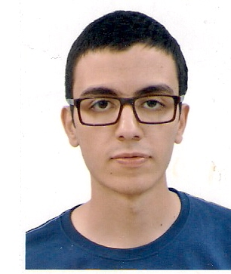 Address : 22 RUE AH 240 lot BC ,Bordj Bou Arreridj

Zip code : 34000

Phone number : +213799575457

Email : [khoudoursofiane75@gmail.com](mailto:khoudoursofiane75@gmail.com)

**Education**:

University of Bordj Bou Arreridj 2014-2017

* Bachelor’s degree in telecommunications :
* Master of Telecommunications Systems (currently)

**Computer skills** :

C++ programing language: intermediate Microsoft Office : Intermediate

HTML and PHP : Advanced

Matlab and Simulink : Advanced

FPGA : Beginner

**Languages** :

Arabic : native French: Fluent English : intermediate Mandarin : beginner

**Certificates** :

EL KHWARIZMI training center : 24/09/2017-03/10/2017

* Linux system administration and software virtualization

New Generation School : 15/08/2016-20/06/2017

* Certificate of appreciation